



BRAINOVISION HACKATHON

REPORT

DETAILS OF THE TEAM:

NAME OF THE TEAM**:** TECH WIZARDS(TEAM-1)

TEAM MEMBERS:

NAME ROLL NO PHNO DEPT

1. G. DHARMATEJA 20471A05L1 7801097670 CSE-D

2. S. SAI ROHIT 20471A05N2 9848616504 CSE-D

3. CH. LIKITHA BHAVYA 20471A05k4 9515257023 CSE-D

4. R. ANJALI 20471A05M5 8096975845 CSE-D

5. G. NITEESH SAI 20471A05L2 9652029589 CSE-D

6. K. YAMINI SAI SRI 21475A0501 9963152185 CSE-D

Url of the website : https://softwarelabs.online

TITLE:

The idea to develop a gym website:

* Due to pandemic many people are suffered with their health .
* So we took an initiative by building a website we can make them a step forward caring about health and fitness.
* By Connecting people in their localities with their nearby locality gyms.
* Providing awareness about the health and fitness.
* To conduct the events related to fitness and health.
* For this making them as a club who are willing to participate.
* Providing information to follow their health diet based on their physical conditions.
* And providing videos to bring awareness how the gym is impact on people day-to-day life and their facilities.

What we learn from the project:

* Team work and team Management.
* Building a website by using tools.
* Building different types of websites.
* Knowing about how hackathons was conducted.
* Brainstorming when we building a website.
* Managing time based on the work.
* Learning new skills to perform a task in efficient way.
* Dealing with non coding tools like word press.
* In word press tools like elmentaor s, plugins , WpForms .

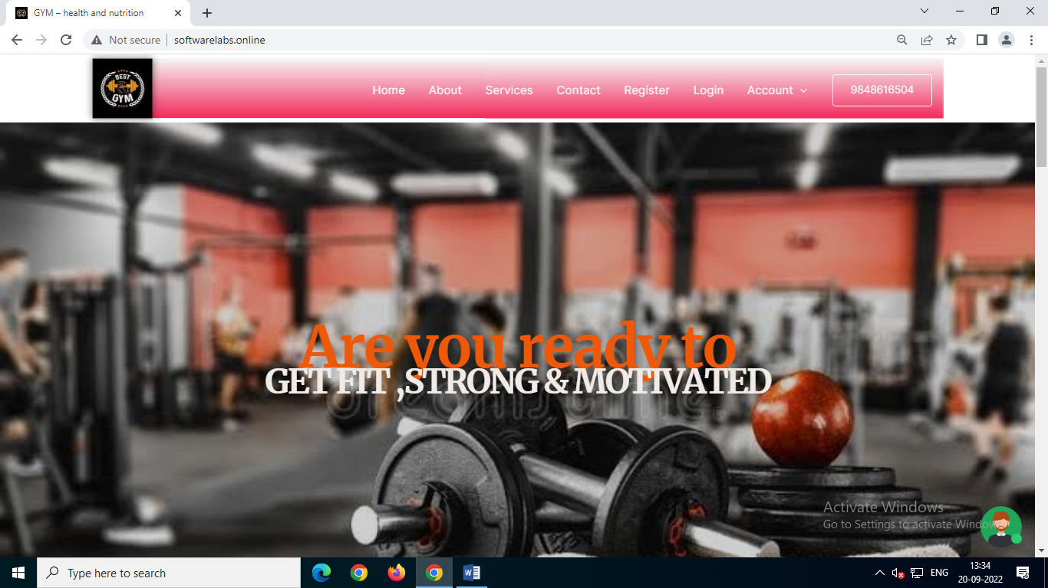

PICTURES RELATED TO OUR WEBSITE:

HOME PAGE

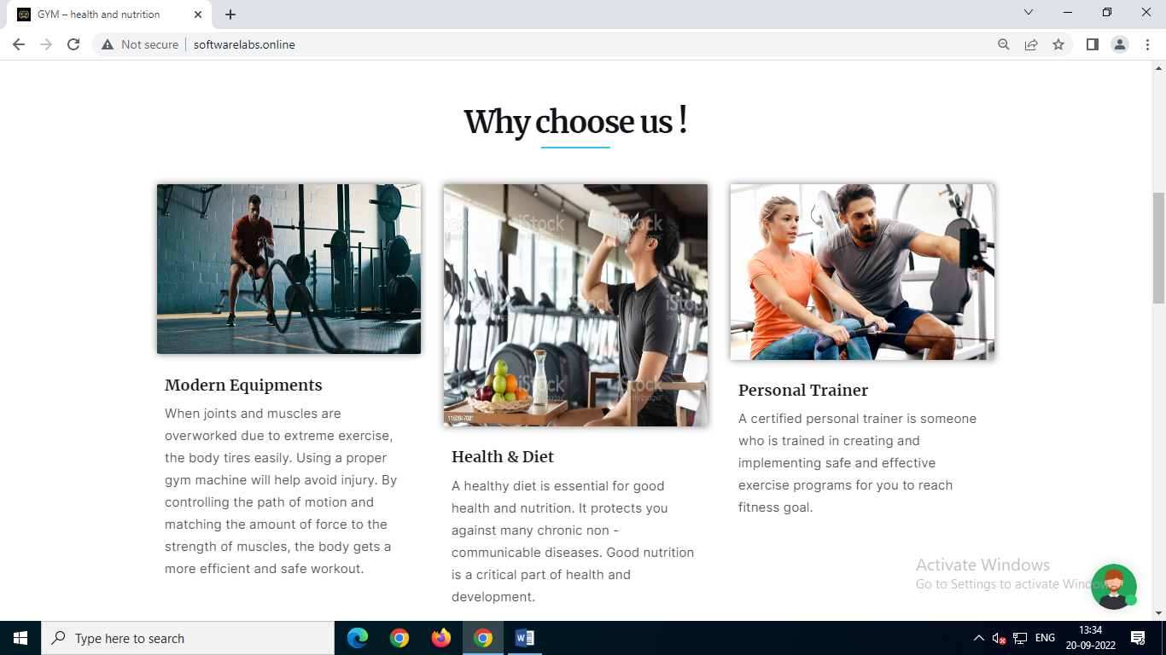

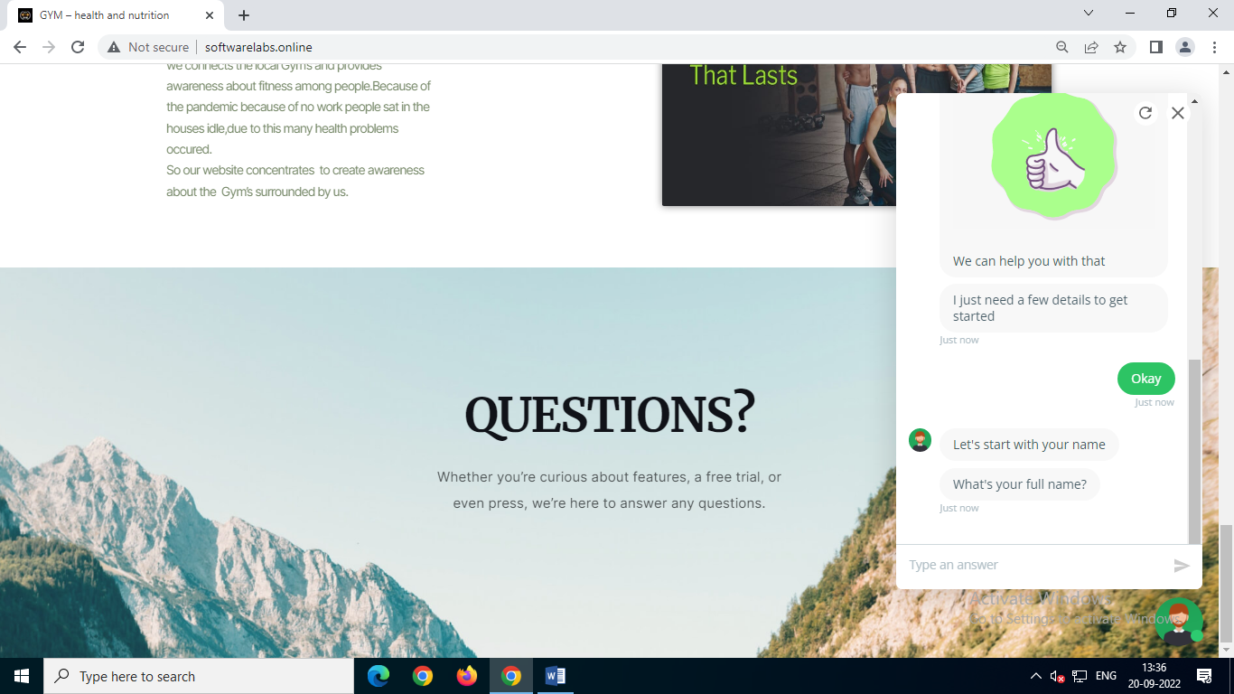

QUERY SECTION

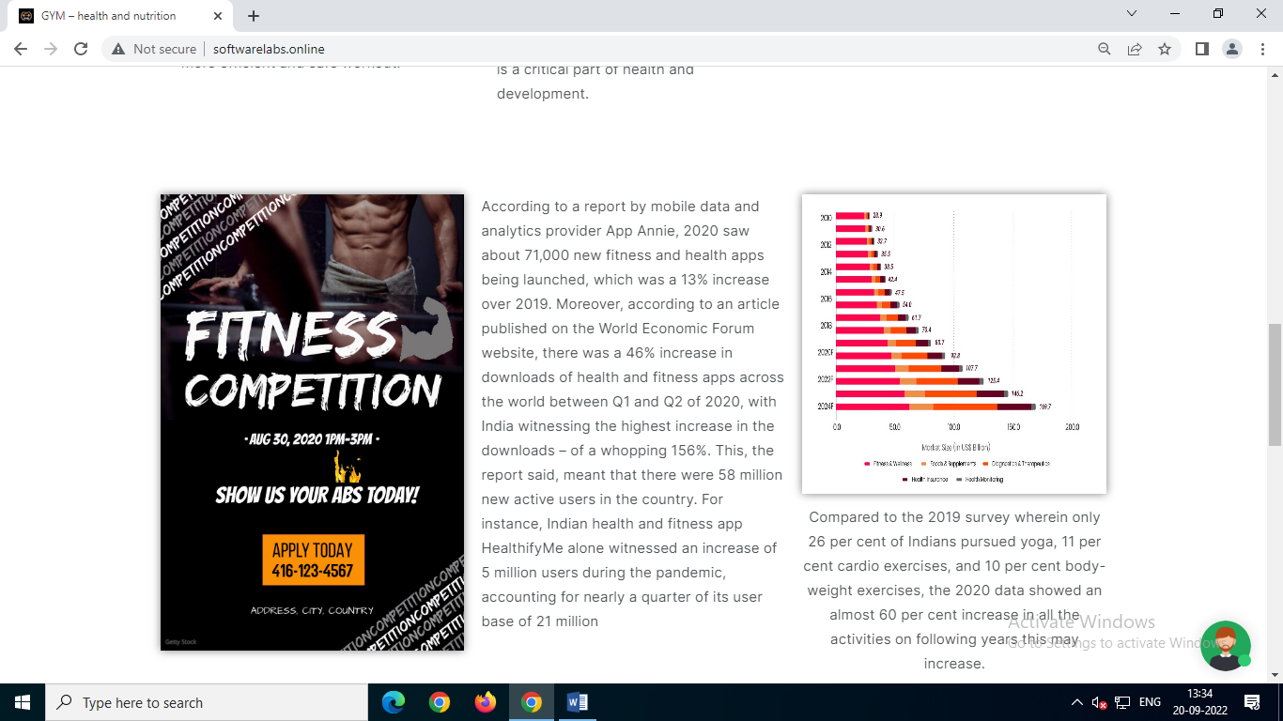

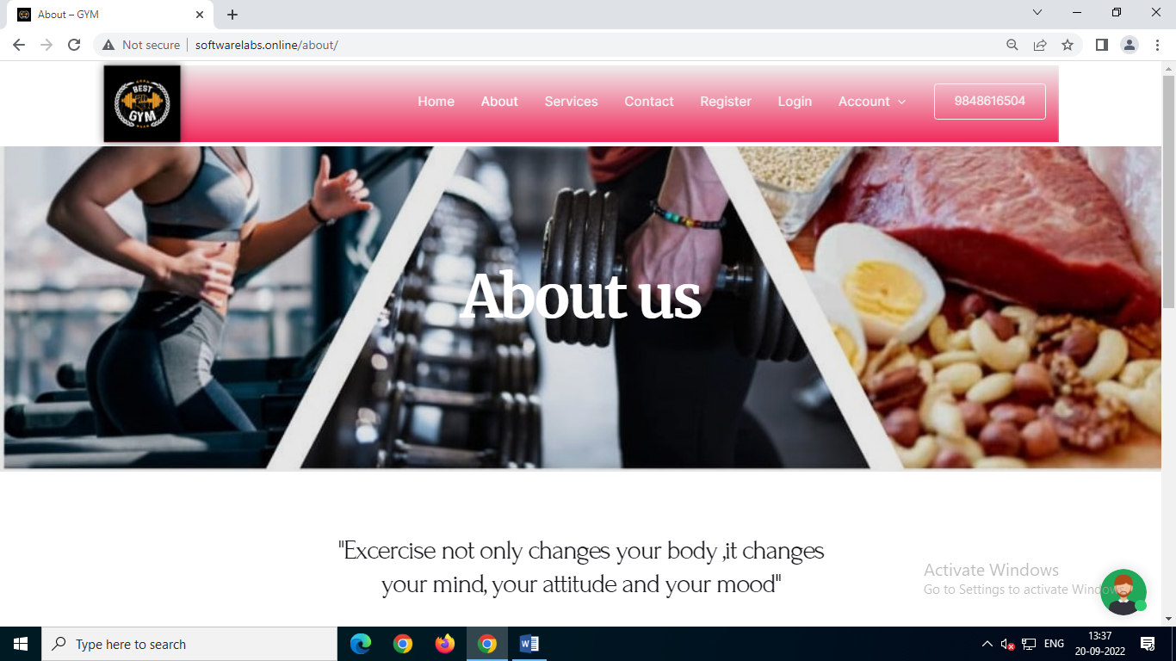

ABOUT US

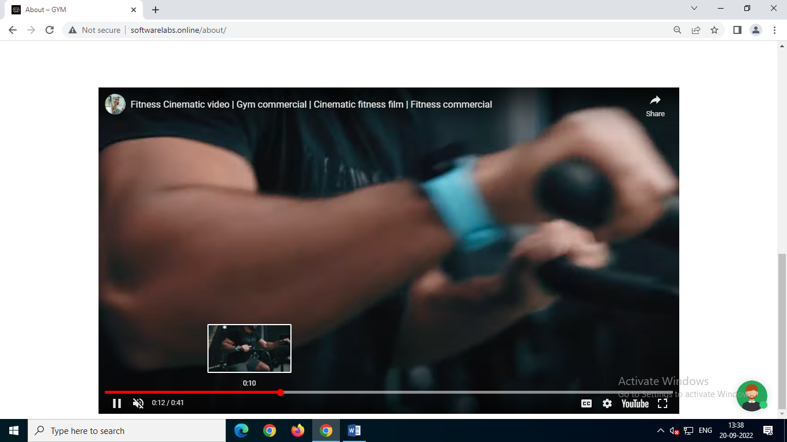

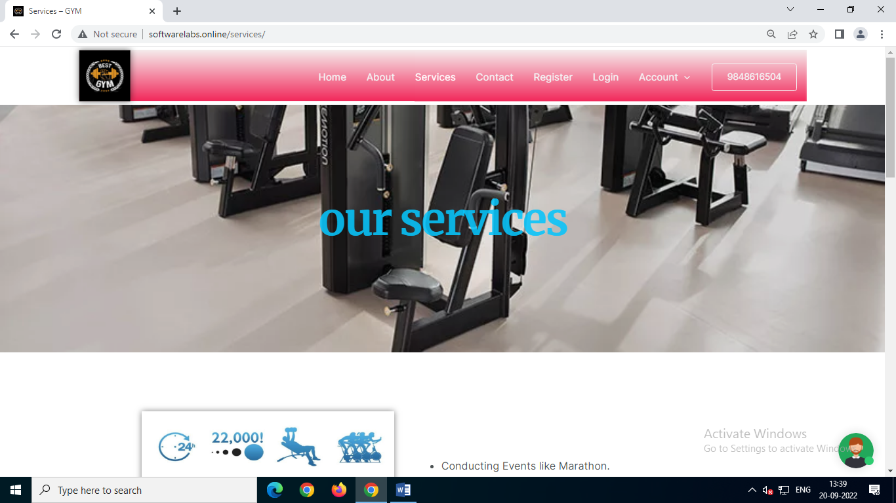

OUR SERVICES AND DIET PLAN

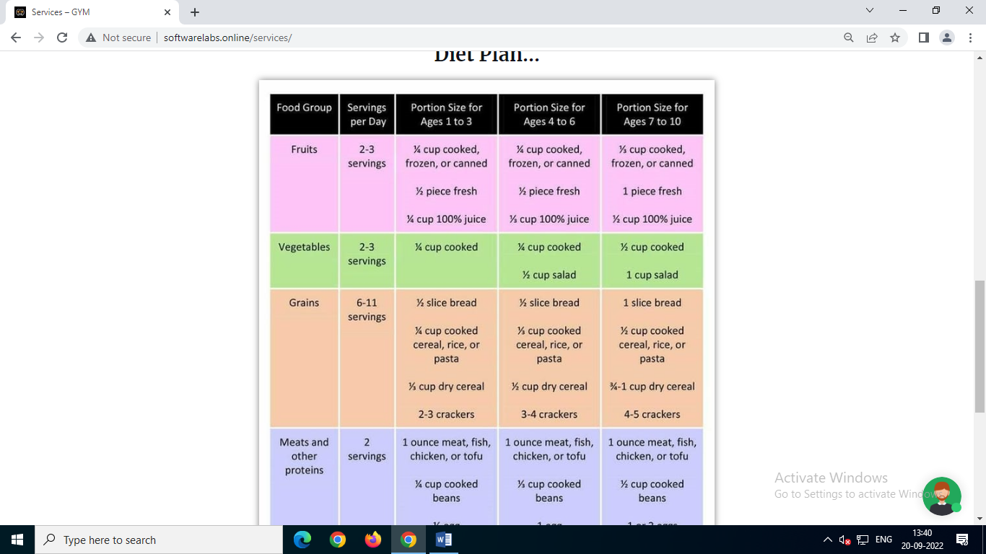

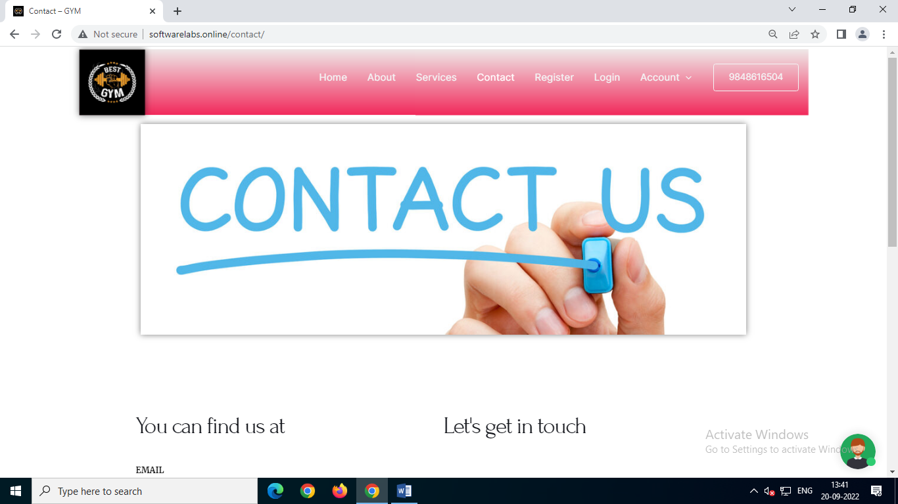

CONTACT US

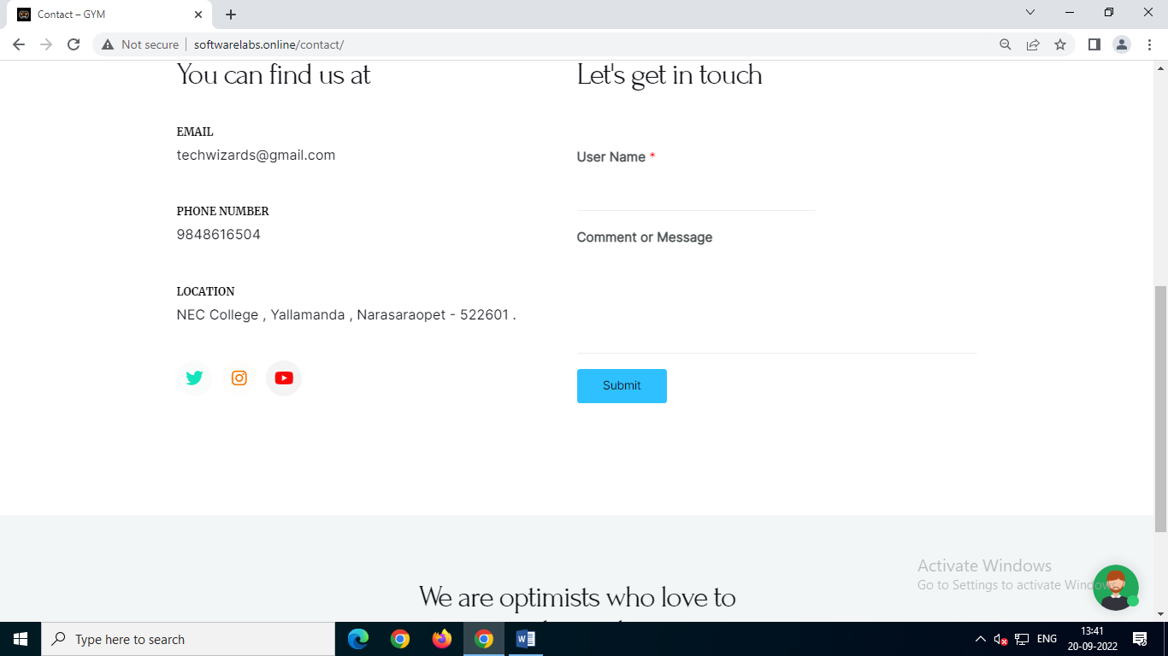

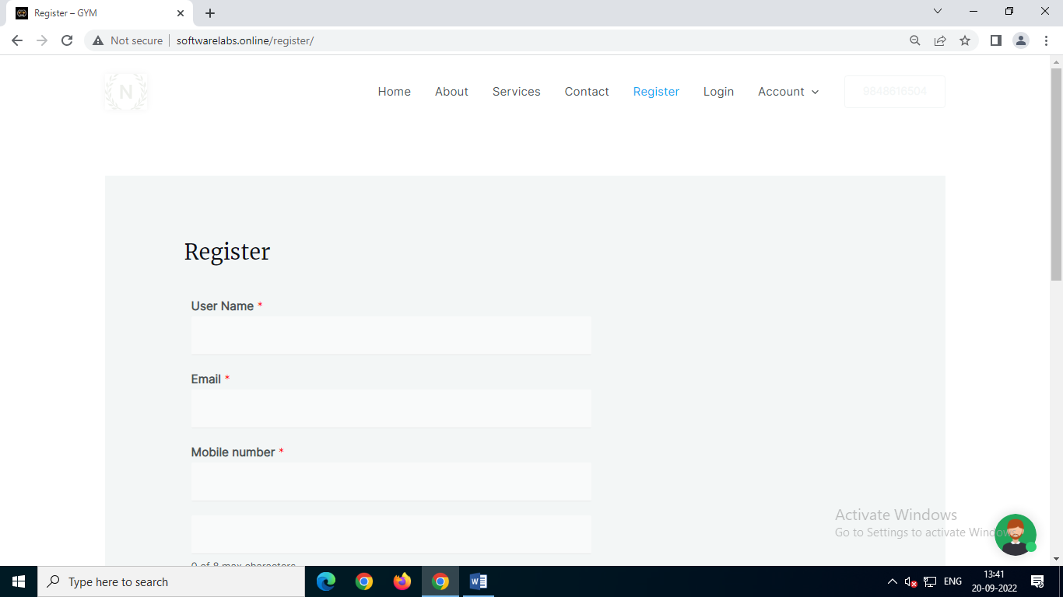

REGISTRATION AND FORMS

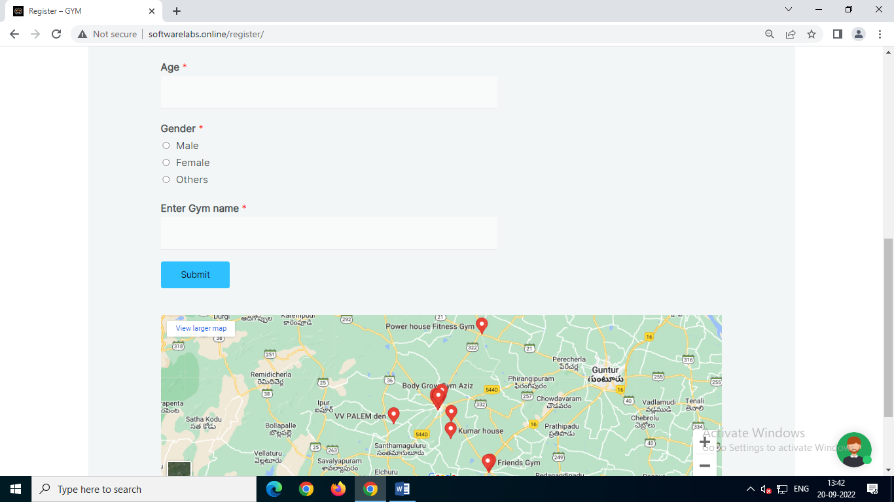

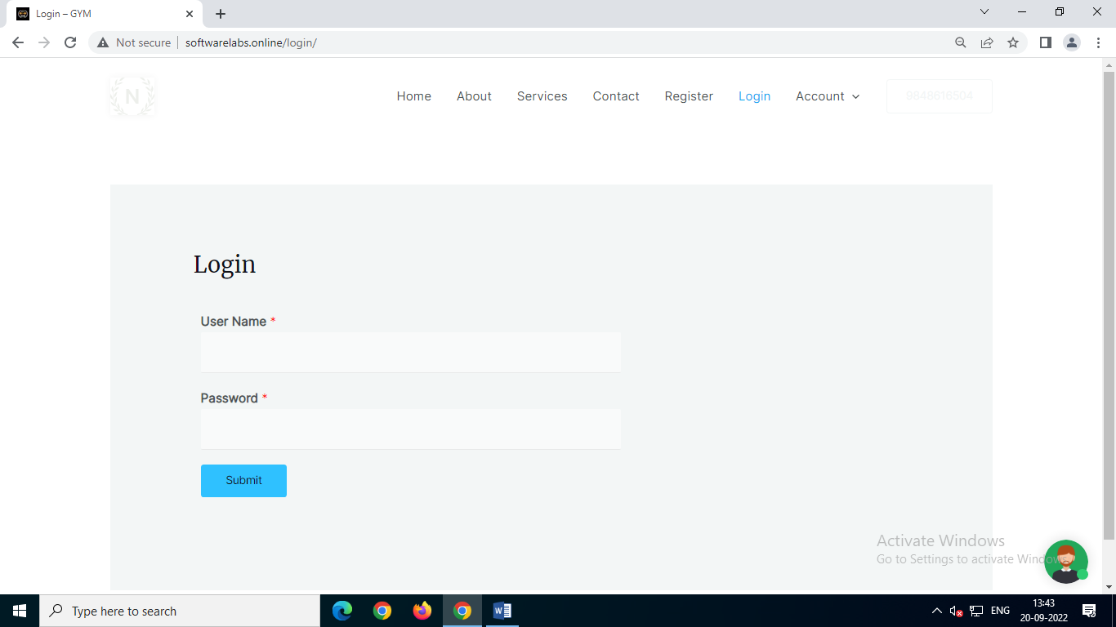

TOOLS USED IN OUR WEBSITE:

* It was build using word press tool.
* In that we used elementor to insert images and writing text.
* wp form used to create forms like registration and login forms.
* collect.chat is used to create chatbot.